Geometry: Unit 10, Lesson H1
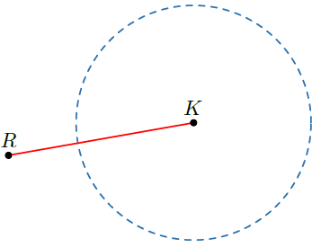
- Julian is constructing the perpendicular bisector of $\overline{KR}$. His incomplete construction is shown. What is the next step that Julian should make in his construction?

Keeping the same compass width the same, place the compass point on point $R$ and draw arcs above and below $\overline{RK}$.

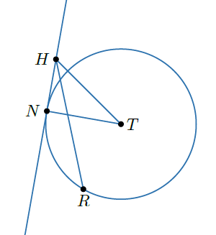
- Circle $T$ is shown, where points $N$ and $R$ lie on the circle and point $H$ lies outside the circle. What line segment is tangent to circle $T$?

$$\overline{NH}$$
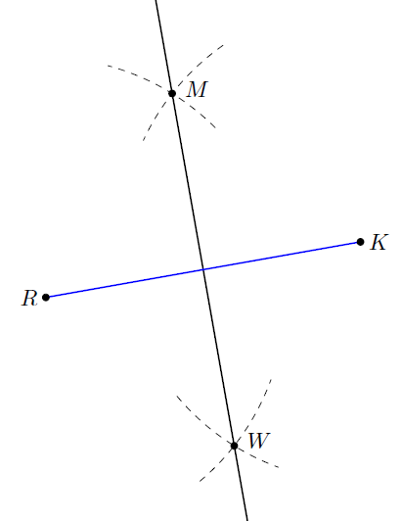
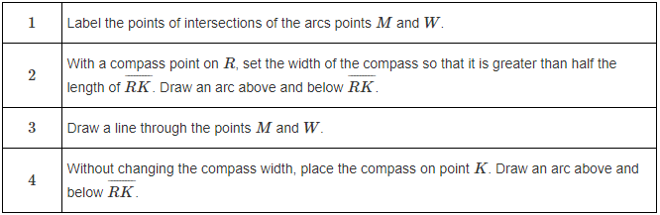
- The construction of the perpendicular bisector of $\overline{KR}$ is shown in the image, and the steps are listen in the table. What is the correct order of the steps in the table?

$$2, 4, 1, 3$$

